

Farhana Fayez, Markus Hirvensalo, Gaurab and Matthias

Life Cycle Assessment (LCA)

Project Report

Helsinki Metropolia University of Applied Sciences

Bachelor of Engineering

Environmental Engineering

18.12.2015

|  |  |  |
| --- | --- | --- |
| Author(s)  Title  Number of Pages  Date | Farhana Fayez, Markus Hirvensalo, Matthias, Gaurab  LCA Project Report  28 pages  20 December 2015 | |
| Degree | Name of the degree | |
| Degree Programme | Environmental Engineering | |
| Specialisation option | - | |
| Instructor(s) | Antti Tohka (Head of DP, Principal Lecturer)  Veli Matti (Principal Lecturer) | |
|  | | |
| Keywords | | LCA, Emissions, Impacts, Cars, Public Transport |

**Table of Contents**

**1 Project Background** 6

**1.1** **Average Car Ages** 6

**1.2** **Average Car 2015** 6

**1.2.1** **Emissions per kilometre** 7

**1.3** **Average Car 2020** 7

**1.3.1** **Emissions per kilometre** 8

**1.4** **Public Transport 2015** 8

**2 Goal and Scope** 8

**2.1** **Intended Application** 9

**2.2** **Functional Unit** 9

**2.3** **System Boundaries** 9

**2.4** **Assumptions and Limitations** 9

3 **Life Cycle Inventory (LCI)** 10

**3.1** **Emissions** 10

**3.2** **Database** 11

**3.3** **Uncertainties** 19

**3.3.1** **Average Number of Passengers** 19

**3.3.2** **Average Age of Car** 20

**3.3.3** **Emissions/Impact Factors** 20

**3.3.4** **Diesel Cars or Petrol cars** 21

**4 Life Cycle Impact Assessment (LCIA**) 21

**4.1** **Impact Categories** 21

**4.1.1** **Classification** 22

**4.2** **Normalisation** 23

**4.3** **Weighing Triangle** 24

**5 Interpretation and Critical review** 25

**6 Recommendations** 26

**7 References** 27

# Project Background

Our consultation company has been given the task to give recommendations to Metropolia, how to reduce environmental impact of traveling between home and Leiritie campus. They are interested in impacts on climate change, eutrophication and health and also travelling cost time wise. The sample number of different addresses are at least 22 and they are partly picked randomly

## **Average Car Ages**

The average age of all registered passenger cars in Finland was 12.6 years at the end of 2012. When cars registered as museum vehicles are excluded, the average age falls to 10.6 years. The average age of passenger cars in traffic was 10.9 years.  
The life span of a vehicle is usually the same, approximately 18–20 years, both for new cars and imported used cars. Some vehicles are decommissioned early due to damage sustained in accidents, while others remain registered for decades as museum cars.

## **Average Car 2015**

According to Trafi, the average age of a car in use in Finland is 11-12 years old.

There has been an increase in the usage of diesel fuelled cars and electric cars.

Increase in electric and hybrid cars will cut down the usage of fuels and CO2 emissions.

According to VTT’s research (LIISA 2012 model) in the year 2015 the amount of CO2 emitted to air by cars (road traffic) is 7 004 231 tonnes.

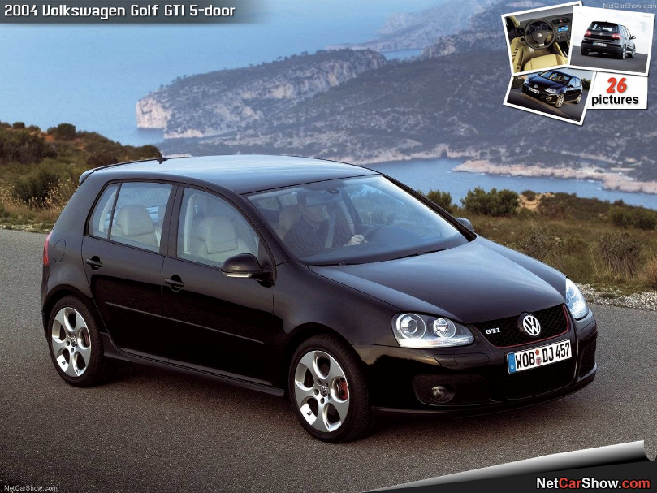

*Image 1: Average car 2015*

Autoalan tiedotuskeskus informs that the average CO2 emissions should be 130g/kg by the year 2015.

### **Emissions per kilometre**

Volkswagen golf 2004, CO2 emissions 160g/km. This car uses gasoline as fuel and has a good efficient motor. I could imagine this is somewhere near the average cars used now in Finland.

## **Average Car 2020**

From trafi’s graph you can see that the increase at the age of the cars used in Finland is in more or less linear growth, so I would estimate the average age to be somewhere between 13 – 14 years old in the year 2020.

According to VTT’s research (LIISA 2012 model) in the year 2020 the amount of CO2 emitted to air by cars (road traffic) is 6 555 105 tonnes.

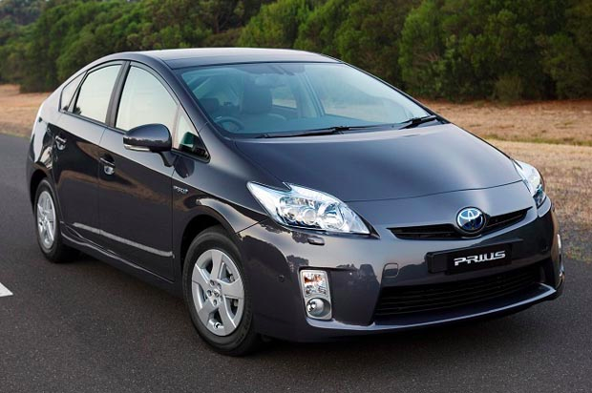

*Image 2: Average car 2020*

Autoalan tiedotuskeskus informs that the average CO2 emissions should be 95g/kg by the year 2020.

### **Emissions per kilometre**

Toyota prius 2008, CO2 emissions 100g/km. This car has a hybrid motor, which is part combustion engine and part electricity engine. This is what I could imagine to be an average car in Finland by the year 2020.

## **Public Transport 2015**

In the Helsinki metropolitan area, the number of passengers on buses average 13 passengers / bus. During peak hours, the passenger numbers may, depending on area, be significantly higher. Emissions from rail traffic (trains, metro, tram) are calculated as zero because they use hydroelectric power. The carbon emission factors for bus results to 73 g/passenger km.

# Goal and Scope

We are following the ISO 14040 and 14044 standards which are part of the [ISO 14000](https://en.wikipedia.org/wiki/ISO_14000) environmental management standards: our LCA study is carried out in four distinct phases. The phases are often interdependent, in that the results of one phase will inform how other phases are completed. The inventory compiled in this project is intended to be used according to the Life Cycle Assessment methodology. The assessment is done on 3 subjects; emissions for car of 2015, car of 2020 and public transport of 2015 and their impacts.

## **Intended Application**

The aim of the project is to analyse environmental impact of traveling between home and Metropolia UAS Leiritie campus and also calculate impacts on climate change, eutrophication and health along with travelling cost time.

## **Functional Unit**

This defines what precisely is being studied and quantifies the service delivered by the product system, providing a reference to which the inputs and outputs can be related in our case it is the study of emissions for a round trip of the journey.

## **System Boundaries**

The system boundaries determine which unit processes to be included in the LCA study. Defining system boundaries is partly based on a subjective choice, made during the scope phase when the boundaries are initially set. We are only taking in account the emissions based on the shortest and fastest route possible by either car or public transport. The other routes are not taken in account.

## **Assumptions and Limitations**

When performing life cycle analyses, the available data will not always be satisfactory. Data is often gathered from a variety of sources, and some data will sometimes not be available. These factors lead to assumptions being made, further leading to uncertainty.

# Life Cycle Inventory (LCI)

Life cycle inventory, which records as many of the requisite types and quantities of material plus as many of the types and quantities of energy needed for the production, utilisation and end of life of a product as possible. This scope determines which items are to be additionally assigned to the product in question and which are not. Such scope is referred to as the system boundary or inventory framework.

## **Emissions**

The inventory consists of the distance between Metropolia UAS Leiritie campus and the respective addresses by Car 2015/2020 and Public transport along with their respective emissions in terms of CO2, NOx and PM

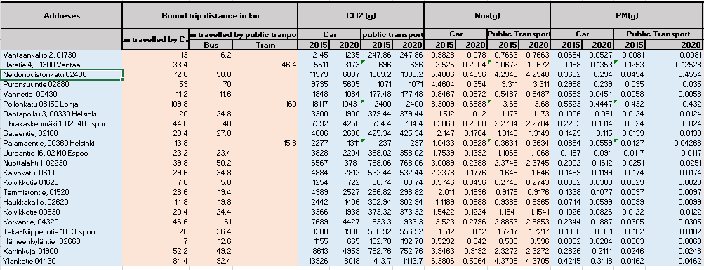*Table 1: Inventory of the emissions*

## The 22 addresses have their round trip distance along with CO2, NOx and PM emissions in grams

## **3.2** **Database**

Our database consists of analysis of normal and lognormal distribution of eutrophication, human toxicity of 2015/ 2020 car and public transport along with an uncertainty histogram which was done through Monte Carlo simulation, or probability simulation, which is a technique used to understand the impact of risk and uncertainty in our emission impact forecasting model.

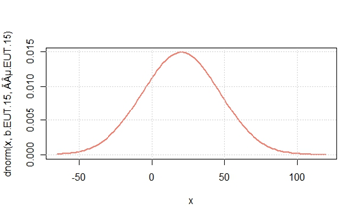

*Normal distribution of the 2015 eutrophication (car*)

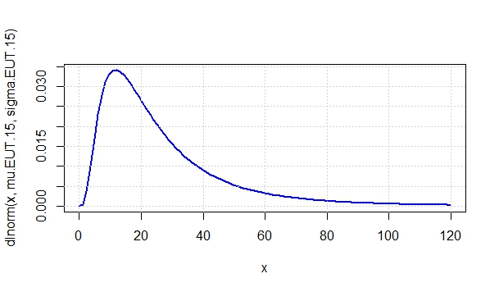

*Lognormal distribution of 2015 eutrophication (car)*

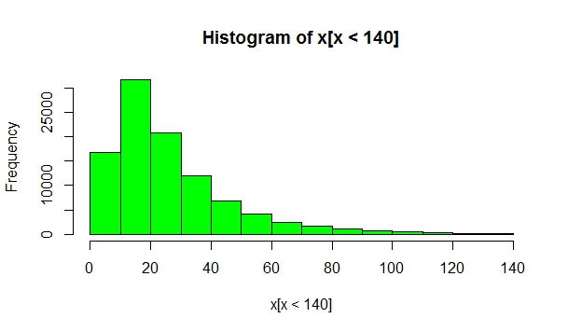

*Histogram of 2015 eutrophication (car)*



*2015 Human toxicity (car)*



*2015 Human toxicity (car)*



*Histogram of 2015 Human toxicity (car)*

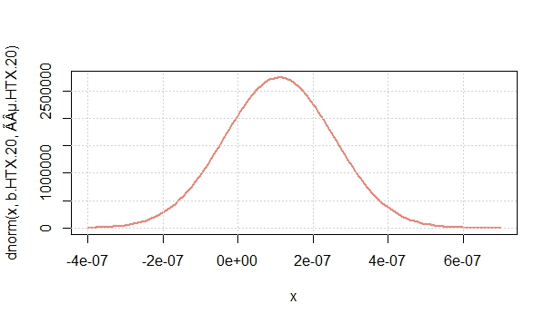

*2020 Eutrophication (car)*

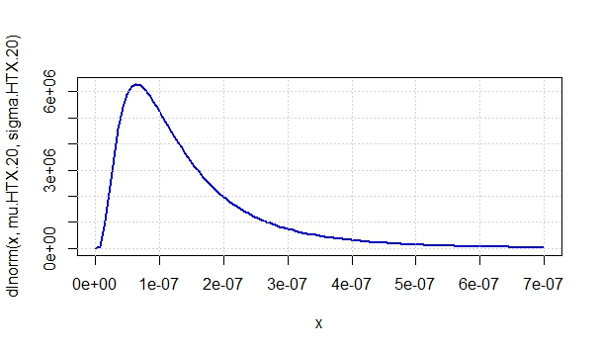

*2020 Eutrophication (car)*

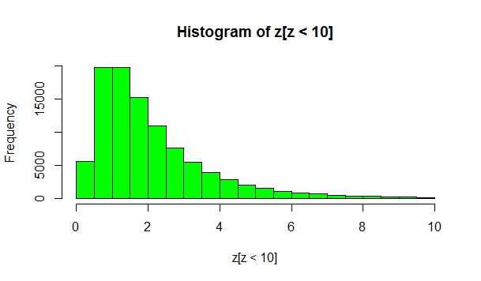

*Histogram of Car 2020 Eutrophication*



*2020 Human toxicity (car)*



*2020 Human toxicity (car)*



*Histogram of Car 2020- Human toxicity*



*Eutrophication Public Transport*



*Eutrophication Public Transport*



*Histogram of Eutrophication Public Transport*



*Human toxicity Public Transport*



*Human toxicity Public Transport*



*Histogram of Human toxicity Public Transport*

We have used R Programming to simulate these graphical analysis and find the uncertainties with these histograms.

**3.2.1 Costs**

Cost analysis are based according to 1 hour per 10 Euros of time based costs.

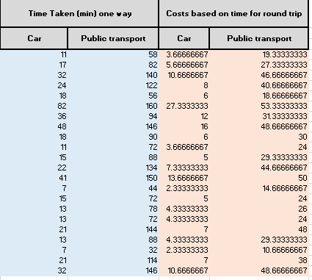

*Time-based costs of public transport and car*

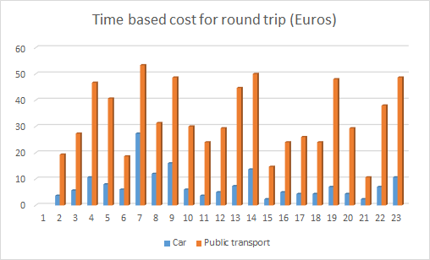

*Graphical illustration of Time-based costs of public transport and car*

The graphical illustration suggest that usage of car is more efficient in terms of time based costs.

## **Uncertainties** Several uncertainties can be identified in this assessment few of them being:

### **Average Number of Passengers**

In our data base we used the information provided by reittiopas.fi and VTTs LIPASTO study, which bought use average number of passengers when calculating emissions. This means that when estimating emissions for one person, the value will be same throughout the day. In reality there is a huge difference when comparing emissions for one person between rush hour and night-time trips with public transport. For more accurate results, it would be good to consider the time when this trip to work and back to home is made.

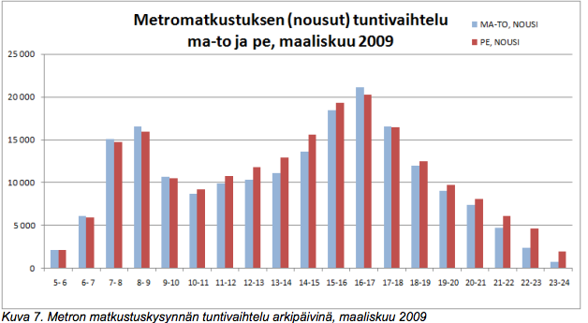

In this chart we can see an example of how the passenger density changes throughout the day. In the x-axis we have time in hours and in y-axis the amount of passengers. You can clearly see that between 7:00-9:00 am and 14:00-18:00 pm the density of passengers is the largest (rush hour). This is a char of metro users from march of 2009.

I would expect similar variations in the passenger density throughout the day in bus and train users.

### **Average Age of Car**

In our emission calculations we used an average car to determine the amount of pollutants it produces. For more accurate results, we should have the age and model of the user’s car to calculate how much it emits pollutants.

When making a rough estimation it is easier to consider just the average, but if you want more accurate results, we need to use real scenarios to determine with better accuracy what are the close to real values.

### **Emissions/Impact Factors**

One the common source of uncertainty is the lack of a universally accepted appropriate official list of environmental impacts to consider.

### **Diesel Cars or Petrol cars**

When determining the emissions of the car, we did not take in account which variant of car should be analysed. As emissions from Diesel and Petrol cars can vary, therefore, those results were not taken in account.

# Life Cycle Impact Assessment (LCIA)

When the scope and goal have been defined and the inventory assembled, an impact assessment is performed. At this phase, one attempts to evaluate potential environmental impacts based on the environmental loads of the Life Cycle Inventory results. The purpose of LCIA is to provide additional information in order to help assess a production system, to better understand the environmental significance of its inventory flows.

## **Impact Categories**

The impact categories that are being assessed are Climate Change, human toxicity and eutrophication.

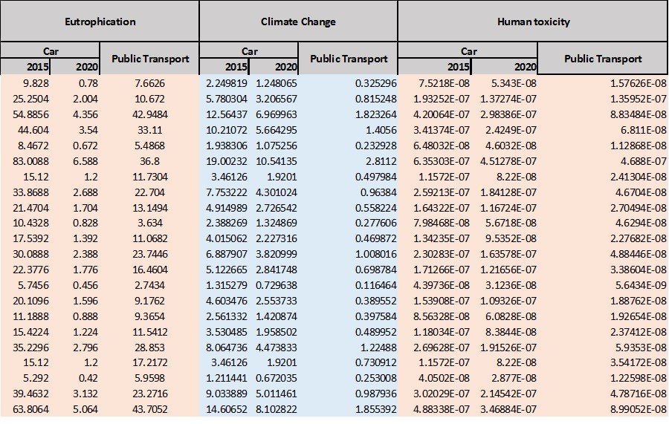

*Inventory of Impact*

### **Classification**

Eutrophication impact calculates potential impacts for all substance that contribute to eutrophication potential. The characterisation model scales substances that include nitrates and phosphates to the common unit.

The human toxicity potential (HTP), a calculated index that reflects the potential harm of a unit of chemical released into the environment, is based on both the inherent toxicity of a compound and its potential dose.

This study also aims to develop a method for evaluating a relative potential impact from climate change to a product system using an LCA framework

## **Normalisation**

First the average values of the three various transportation systems were calculated for every impact category.

|  |  |  |  |  |
| --- | --- | --- | --- | --- |
|  | **Eutrophication** | **Climate Change** | **Human Toxicity** | **Required Time** |
| **Unit** | **Eutrophication equivalent** | **CO2 equivalent** | **Daily** | **min** |
| **Car 2015** | 26,7 | 6,1 | 2,0E-07 | 23,5 |
| **Car 2020** | 2,1 | 3,4 | 1,5E-07 | 23,5 |
| **Public Transport** | 17,8 | 0,8 | 6,1E-08 | 99,2 |

*Average Results for round trips of step 2*

In the next step, these values were normalized by dividing them with certain normalisation factors. These factors can be seen in the following table and were made up by ourselves. Normalisation is performed to make the effect scores of the environmental profile comparable.

|  |  |
| --- | --- |
| Eutrophication | 3 |
| Climate Change | 1 |
| Human toxicity | 0.0000001 |
| Required time | 10 |

*Estimated Normalisation factors*

The results of the normalisation procedure are visible in the diagram below. Now a comparison between the different ways of travelling is possible.

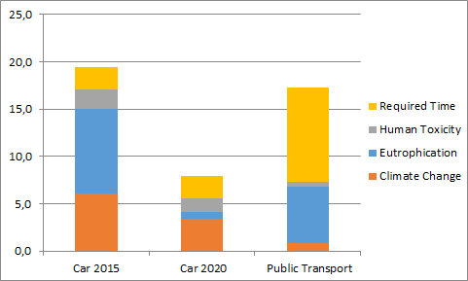

*Normalized Results of the three transport facilities*

The environmental profile is only put in a broader context, which makes the interpretation easier.

## **Weighing Triangle**

The triangle indicates to what extent the result of an analysis is dependent on weighting factors. This approach can be used if three damage categories are taken into account.

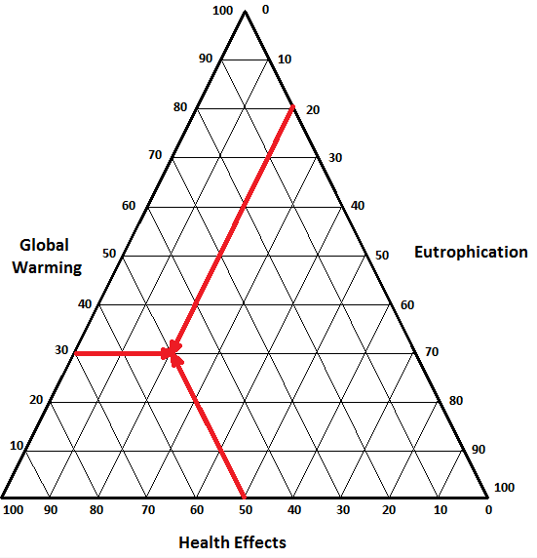

*Weighting Triangle*

The sum of the three weighting factors represents 100%, so let us assume that it equals 100. Figure can be distributed in different ratios between damage categories, e.g. 50 for human health, 40 for ecosystem quality and 10 for resource depletion.

# Interpretation and Critical review

The normalized results of different modes of transportations give clear indications on the extent of impact on climate change, eutrophication, and human toxicity as well time. The differences in values for 2015 average car and 2020 average car is quite significant. All the environmental impact category values have better score in 2020,but the time taken values understandably remain the same. Meanwhile all of the impact categories have better score compared to 2015 average car but 2020 average car score better than public transportation. Another major advantage of a private transport seems to be the time taken values, the values for which is almost double for public transport compared to average cars. As for the weighting triangle, Health effects (Human toxicity) has been allocated 50% while global warming gets 30% and eutrophication gets 20%.

The most notable aspect of the study seems to be the significant improvement i.e. lower values of impact categories for average 2020 car compared to 2015.This is due to the reason that new cars after 2014 (Euro Category 6) have to comply with emission limits that set NOx emissions to 0.080 g/km; this is more than half to Euro category 5b cars. Also older models will be phased out or improvement on the engines and exhaust will be required. The lower values of time for cars is quite obvious because of the direct route while taking the private vehicle. The assumption is done with regard to normal route i.e without traffic jams or rush hour, which as we know is impossible for private vehicles. Also the emission values for the average cars 2015 and 2020 have been taken calculated for three people but that is rarely the case in real life. If those values are calculated for a single person then the values will certainly be different. Also the public transportation is assumed to be stagnant in terms of emission values but newer buses added will also have better emission value that will have positive effect on the impact categories.

# Recommendations

This study on mode of transportation has shown that public transportation is still the better option in terms of environmental impacts but if time value that is calculated in terms of time, cars are better option. Therefore if public transportation use is to be encouraged, better design of the routes with fewer stops and direct access has to be considered. Newer fleet of buses added need to have better engines and exhaust system that can rival the lighter private vehicles. Perhaps adding cleaner vehicles e.g. hydrogen fuelled buses or electric buses could be the option.

# References

(2015). Available at: http://lipasto.vtt.fi/indexe.htm (Accessed: 20 December 2015).

(2015). Available at: https://www.google.fi/search?q=volkswagen+golf+2004&espv=2&source=lnms&tbm=isch&sa=X&ved=0CAcQ_AUoAWoVChMIlMjk_OfLxwIVTJIsCh0n4AP2&biw=1440&bih=778#imgrc=KLLfYaYN59-3AM%3A (Accessed: 20 December 2015).

(2015). Available at: https://www.google.fi/search?q=toyota+prius+2018&espv=2&source=lnms&tbm=isch&sa=X&ved=0CAcQ_AUoAWoVChMI757ymvLLxwIVZXdyCh05Vwq5&biw=1440&bih=778#imgrc=wYI2Rmg3o0M9sM%3A (Accessed: 20 December 2015).

1st ed (2015). Available at: http://www.trafi.fi/filebank/a/1385544081/aacede60b181fe7444e0cd3d57ddfc51/13667-Trafi_Tieliikenteen_turvallisuuskatsaus_2013_eng.pdf (Accessed: 20 December 2015).

1st ed (2015). Available at: https://www.hsl.fi/sites/default/files/uploads/metron_yoliikenteen_laajentamisselvitys.pdf (Accessed: 20 December 2015).

1st ed (2015). Available at: http://www.theicct.org/sites/default/files/publications/ICCTupdate_EU-95gram_jan2014.pdf (Accessed: 20 December 2015).

Autoscout24.de, (2015) *Gebrauchtwagen und Neuwagen bei AutoScout24*. Available at: http://www.autoscout24.de/ (Accessed: 20 December 2015).

Google Maps, (2015) *Google Maps*. Available at: https://www.google.fi/maps/ (Accessed: 20 December 2015).

Reittiopas.fi, (2015) *Reittiopas*. Available at: http://www.reittiopas.fi/ (Accessed: 20 December 2015).

Wikipedia, (2015) *European emission standards*. Available at: http://en.wikipedia.org/wiki/European_emission_standards (Accessed: 20 December 2015).

Wikipedia, (2015) *Life-cycle assessment*. Available at: https://en.wikipedia.org/wiki/Life-cycle_assessment#Goal_and_scope (Accessed: 20 December 2015).